Introducing VLANs

Introducing VLANs

Before VLANs
To appreciate why VLANs are being widely used today, consider a small community college with student dorms and the faculty offices all in one building. The figure shows the student computers in one LAN and the faculty computers in another LAN. This works fine because each department is physically together, so it is easy to provide them with their network resources.

Click the Many Buildings button in the figure.
A year later, the college has grown and now has three buildings. In the figure, the original network is the same, but student and faculty computers are spread out across three buildings. The student dorms remain on the fifth floor and the faculty offices remain on the third floor. However, now the IT department wants to ensure that student computers all share the same security features and bandwidth controls. How can the network accommodate the shared needs of the geographically separated departments? Do you create a large LAN and wire each department together? How easy would it be to make changes to that network? It would be great to group the people with the resources they use regardless of their geographic location, and it would make it easier to manage their specific security and bandwidth needs.
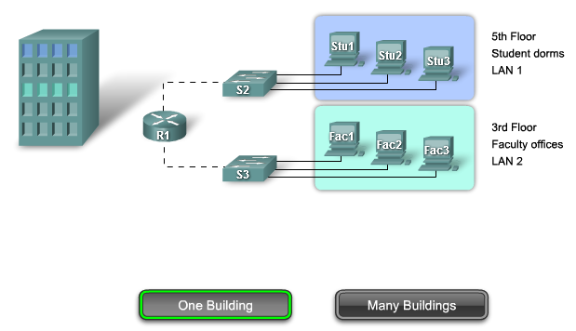
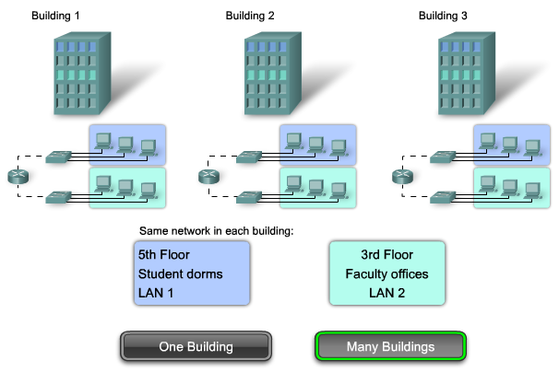

VLAN Overview
The solution for the community college is to use a networking technology called a virtual LAN (VLAN). A VLAN allows a network administrator to create groups of logically networked devices that act as if they are on their own independent network, even if they share a common infrastructure with other VLANs. When you configure a VLAN, you can name it to describe the primary role of the users for that VLAN. As another example, all of the student computers in a school can be configured in the "Student" VLAN. Using VLANs, you can logically segment switched networks based on functions, departments, or project teams. You can also use a VLAN to geographically structure your network to support the growing reliance of companies on home-based workers. In the figure, one VLAN is created for students and another for faculty. These VLANs allow the network administrator to implement access and security policies to particular groups of users. For example, the faculty, but not the students, can be allowed access to e-learning management servers for developing online course materials.

Click the Details button in the figure.

VLAN Details
A VLAN is a logically separate IP subnetwork. VLANs allow multiple IP networks and subnets to exist on the same switched network. The figure shows a network with three computers. For computers to communicate on the same VLAN, each must have an IP address and a subnet mask that is consistent for that VLAN. The switch has to be configured with the VLAN and each port in the VLAN must be assigned to the VLAN. A switch port with a singular VLAN configured on it is called an access port. Remember, just because two computers are physically connected to the same switch does not mean that they can communicate. Devices on two separate networks and subnets must communicate via a router (Layer 3), whether or not VLANs are used. You do not need VLANs to have multiple networks and subnets on a switched network, but there are definite advantages to using VLANs.
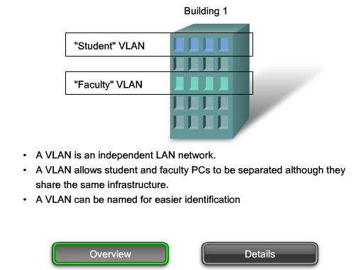
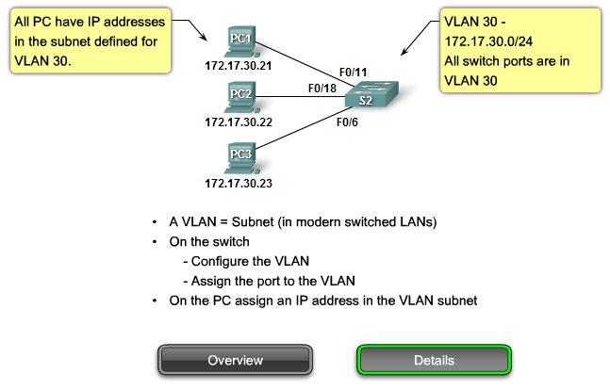

Benefits of a VLAN
User productivity and network adaptability are key drivers for business growth and success. Implementing VLAN technology enables a network to more flexibly support business goals. The primary benefits of using VLANs are as follows:
- Security - Groups that have sensitive data are separated from the rest of the network, decreasing the chances of confidential information breaches. Faculty computers are on VLAN 10 and completely separated from student and guest data traffic.
- Cost reduction - Cost savings result from less need for expensive network upgrades and more efficient use of existing bandwidth and uplinks.
- Higher performance - Dividing flat Layer 2 networks into multiple logical workgroups (broadcast domains) reduces unnecessary traffic on the network and boosts performance.
- Broadcast storm mitigation - Dividing a network into VLANs reduces the number of devices that may participate in a broadcast storm. As discussed in the "Configure a Switch" chapter, LAN segmentation prevents a broadcast storm from propagating to the whole network. In the figure you can see that although there are six computers on this network, there are only three broadcast domains: Faculty, Student, and Guest.
- Improved IT staff efficiency - VLANs make it easier to manage the network because users with similar network requirements share the same VLAN. When you provision a new switch, all the policies and procedures already configured for the particular VLAN are implemented when the ports are assigned. It is also easy for the IT staff to identify the function of a VLAN by giving it an appropriate name. In the figure, for easy identification VLAN 20 could be named "Student", VLAN 10 could be named "Faculty", and VLAN 30 "Guest."
- Simpler project or application management - VLANs aggregate users and network devices to support business or geographic requirements. Having separate functions makes managing a project or working with a specialized application easier, for example, an e-learning development platform for faculty. It is also easier to determine the scope of the effects of upgrading network services.
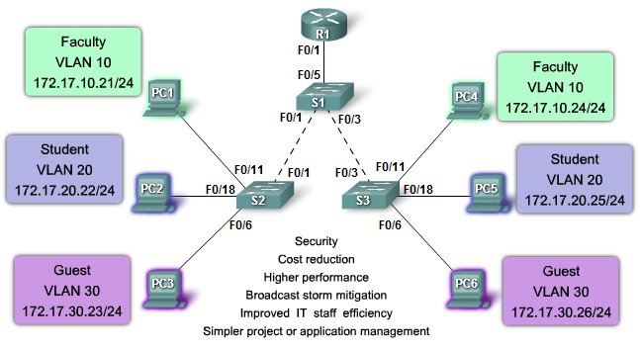

VLAN ID Ranges
Access VLANs are divided into either a normal range or an extended range.

Normal Range VLANs
- Used in small- and medium-sized business and enterprise networks.
- Identified by a VLAN ID between 1 and 1005.
- IDs 1002 through 1005 are reserved for Token Ring and FDDI VLANs.
- IDs 1 and 1002 to 1005 are automatically created and cannot be removed. You will learn more about VLAN 1 later in this chapter.
- Configurations are stored within a VLAN database file, called vlan.dat. The vlan.dat file is located in the flash memory of the switch.
- The VLAN trunking protocol (VTP), which helps manage VLAN configurations between switches, can only learn normal range VLANs and stores them in the VLAN database file.

Extended Range VLANs

- Enable service providers to extend their infrastructure to a greater number of customers. Some global enterprises could be large enough to need extended range VLAN IDs.
- Are identified by a VLAN ID between 1006 and 4094.
- Support fewer VLAN features than normal range VLANs.
- Are saved in the running configuration file.
- VTP does not learn extended range VLANs.

255 VLANs Configurable
One Cisco Catalyst 2960 switch can support up to 255 normal range and extended range VLANs, although the number configured affects the performance of the switch hardware. Because an enterprise network may need a switch with a lot of ports, Cisco has developed enterprise-level switches that can be joined or stacked together to create a single switching unit consisting of nine separate switches. Each separate switch can have 48 ports, which totals 432 ports on a single switching unit. In this case, the 255 VLAN limit per single switch could be a constraint for some enterprise customers.
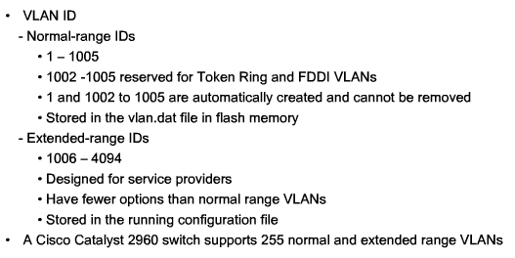

Types of VLANs
Today there is essentially one way of implementing VLANs - port-based VLANs. A port-based VLAN is associated with a port called an access VLAN.
However in the network there are a number of terms for VLANs. Some terms define the type of network traffic they carry and others define a specific function a VLAN performs. The following describes common VLAN terminology:

Rollover the Data VLAN button in the figure.

Data VLAN
A data VLAN is a VLAN that is configured to carry only user-generated traffic. A VLAN could carry voice-based traffic or traffic used to manage the switch, but this traffic would not be part of a data VLAN. It is common practice to separate voice and management traffic from data traffic. The importance of separating user data from switch management control data and voice traffic is highlighted by the use of a special term used to identify VLANs that only carry user data - a "data VLAN". A data VLAN is sometimes referred to as a user VLAN.
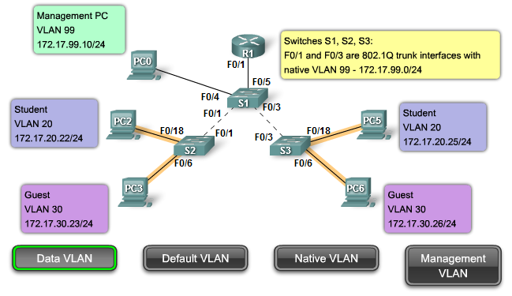

Default VLAN
All switch ports become a member of the default VLAN after the initial boot up of the switch. Having all the switch ports participate in the default VLAN makes them all part of the same broadcast domain. This allows any device connected to any switch port to communicate with other devices on other switch ports. The default VLAN for Cisco switches is VLAN 1. VLAN 1 has all the features of any VLAN, except that you cannot rename it and you can not delete it. Layer 2 control traffic, such as CDP and spanning tree protocol traffic, will always be associated with VLAN 1 - this cannot be changed. In the figure, VLAN 1 traffic is forwarded over the VLAN trunks connecting the S1, S2, and S3 switches. It is a security best practice to change the default VLAN to a VLAN other than VLAN 1; this entails configuring all the ports on the switch to be associated with a default VLAN other than VLAN 1. VLAN trunks support the transmission of traffic from more than one VLAN. Although VLAN trunks are mentioned throughout this section, they are explained in the next section on VLAN trunking.
Note: Some network administrators use the term "default VLAN" to mean a VLAN other than VLAN 1 defined by the network administrator as the VLAN that all ports are assigned to when they are not in use. In this case, the only role that VLAN 1 plays is that of handling Layer 2 control traffic for the network.
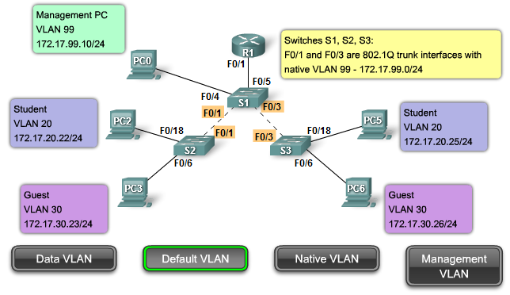

Native VLAN
A native VLAN is assigned to an 802.1Q trunk port. An 802.1Q trunk port supports traffic coming from many VLANs (tagged traffic) as well as traffic that does not come from a VLAN (untagged traffic). The 802.1Q trunk port places untagged traffic on the native VLAN. In the figure, the native VLAN is VLAN 99. Untagged traffic is generated by a computer attached to a switch port that is configured with the native VLAN. Native VLANs are set out in the IEEE 802.1Q specification to maintain backward compatibility with untagged traffic common to legacy LAN scenarios. For our purposes, a native VLAN serves as a common identifier on opposing ends of a trunk link. It is a best practice to use a VLAN other than VLAN 1 as the native VLAN.
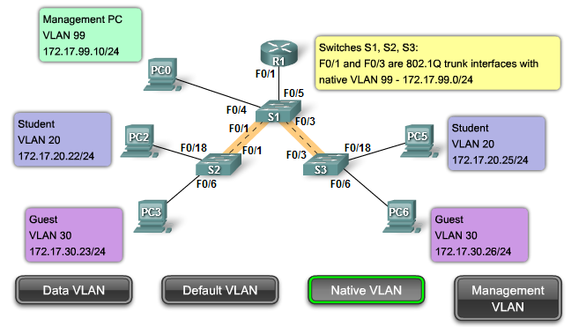

Management VLAN
A management VLAN is any VLAN you configure to access the management capabilities of a switch. VLAN 1 would serve as the management VLAN if you did not proactively define a unique VLAN to serve as the management VLAN. You assign the management VLAN an IP address and subnet mask. A switch can be managed via HTTP, Telnet, SSH, or SNMP. Since the out-of-the-box configuration of a Cisco switch has VLAN 1 as the default VLAN, you see that VLAN 1 would be a bad choice as the management VLAN; you wouldn't want an arbitrary user connecting to a switch to default to the management VLAN. Recall that you configured the management VLAN as VLAN 99 in the Basic Switch Concepts and Configuration chapter.
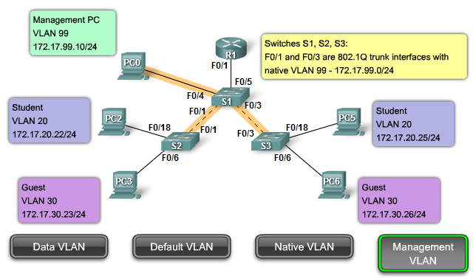

Voice VLANs
It is easy to appreciate why a separate VLAN is needed to support Voice over IP (VoIP). Imagine you are receiving an emergency call and suddenly the quality of the transmission degrades so much you cannot understand what the caller is saying. VoIP traffic requires:
- Assured bandwidth to ensure voice quality
- Transmission priority over other types of network traffic
- Ability to be routed around congested areas on the network
- Delay of less than 150 milliseconds (ms) across the network
To meet these requirements, the entire network has to be designed to support VoIP. The details of how to configure a network to support VoIP are beyond the scope of the course, but it is useful to summarize how a voice VLAN works between a switch, a Cisco IP phone, and a computer.
In the figure, VLAN 150 is designed to carry voice traffic. The student computer PC5 is attached to the Cisco IP phone, and the phone is attached to switch S3. PC5 is in VLAN 20, which is used for student data. The F0/18 port on S3 is configured to be in voice mode so that it will tell the phone to tag voice frames with VLAN 150. Data frames coming through the Cisco IP phone from PC5 are left untagged. Data destined for PC5 coming from port F0/18 is tagged with VLAN 20 on the way to the phone, which strips the VLAN tag before the data is forwarded to PC5. Tagging refers to the addition of bytes to a field in the data frame which is used by the switch to identify which VLAN the data frame should be sent to. You will learn later about how data frames are tagged.
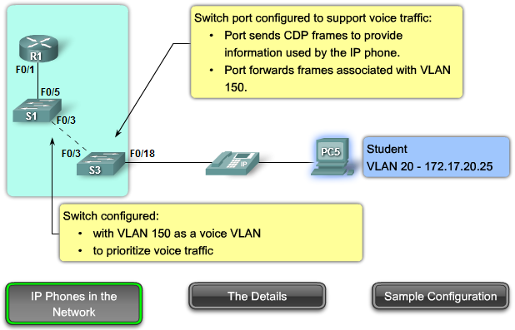

A Cisco Phone is a Switch
The Cisco IP Phone contains an integrated three-port 10/100 switch as shown in the Figure. The ports provide dedicated connections to these devices:
- Port 1 connects to the switch or other voice-over-IP (VoIP) device.
- Port 2 is an internal 10/100 interface that carries the IP phone traffic.
- Port 3 (access port) connects to a PC or other device.
The figure shows one way to connect an IP Phone.
The voice VLAN feature enables switch ports to carry IP voice traffic from an IP phone. When the switch is connected to an IP Phone, the switch sends messages that instruct the attached IP phone to send voice traffic tagged with the voice VLAN ID 150. The traffic from the PC attached to the IP Phone passes through the IP phone untagged. When the switch port has been configured with a voice VLAN, the link between the switch and the IP phone acts as a trunk to carry both the tagged voice traffic and untagged data traffic.
Note: Communication between the switch and IP phone is facilitated by the CDP protocol. This protocol is discussed in greater detail in the CCNA Exploration: Routing Protocols and Concepts course.
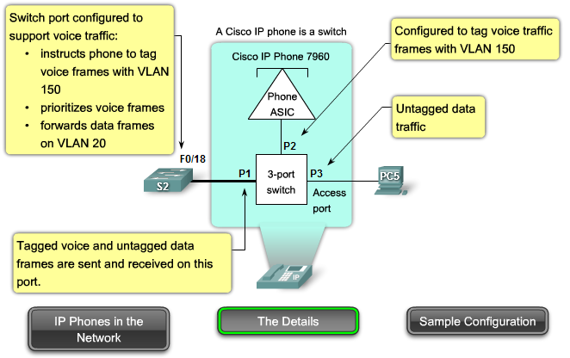

Sample Configuration
The figure shows sample output. A discussion of the Cisco IOS commands are beyond the scope of this course, but you can see that the highlighted areas in the sample output show the F0/18 interface configured with a VLAN configured for data (VLAN 20) and a VLAN configured for voice (VLAN 150).
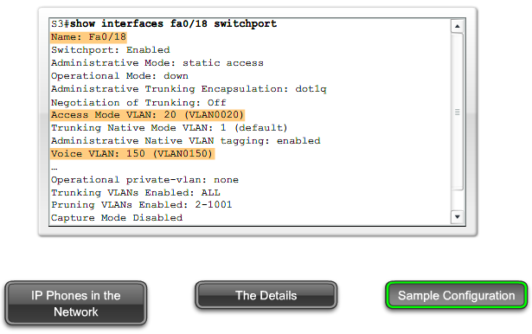

Network Traffic Types
In CCNA Exploration: Network Fundamentals, you learned about the different kinds of traffic a LAN handles. Because a VLAN has all the characteristics of a LAN, a VLAN must accommodate the same network traffic as a LAN.

Network Management and Control Traffic
Many different types of network management and control traffic can be present on the network, such as Cisco Discovery Protocol (CDP) updates, Simple Network Management Protocol (SNMP) traffic, and Remote Monitoring (RMON) traffic.
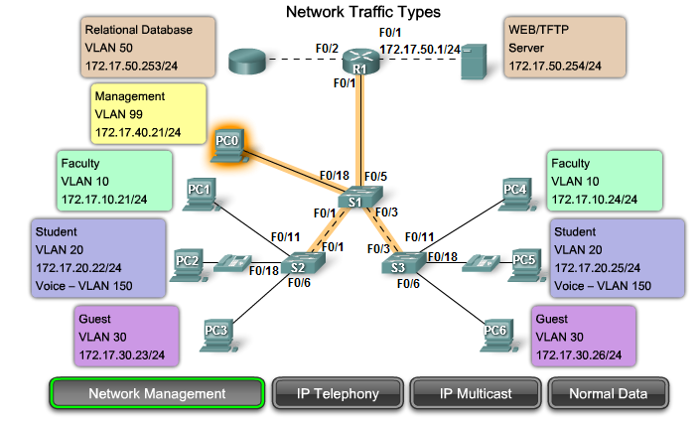

IP Telephony
The types of IP telephony traffic are signaling traffic and voice traffic. Signaling traffic is, responsible for call setup, progress, and teardown, and traverses the network end to end. The other type of telephony traffic consists of data packets of the actual voice conversation. As you just learned, in a network configured with VLANs, it is strongly recommended to assign a VLAN other than VLAN 1 as the management VLAN. Data traffic should be associated with a data VLAN (other than VLAN 1), and voice traffic is associated with a voice VLAN.
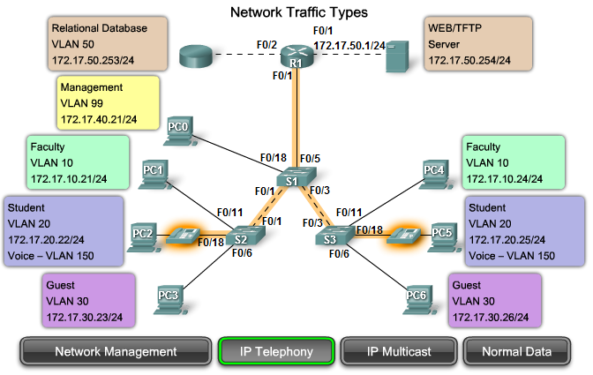

IP Multicast
IP multicast traffic is sent from a particular source address to a multicast group that is identified by a single IP and MAC destination-group address pair. Examples of applications that generate this type of traffic are Cisco IP/TV broadcasts. Multicast traffic can produce a large amount of data streaming across the network. When the network must support multicast traffic, VLANs should be configured to ensure multicast traffic only goes to those user devices that use the service provided, such as remote video or audio applications. Routers must be configured to ensure that multicast traffic is forwarded to the network areas where it is requested.
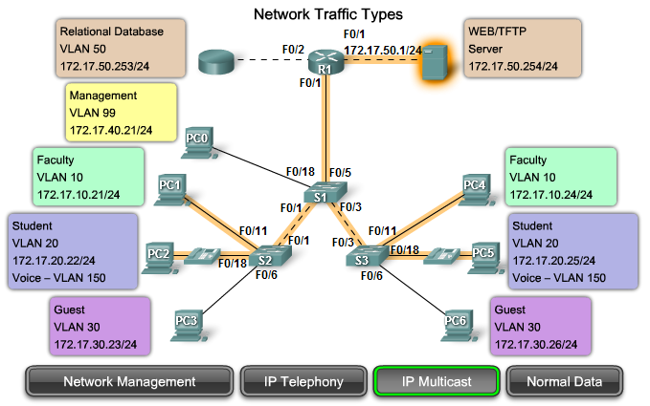

Normal Data
Normal data traffic is related to file creation and storage, print services, e-mail database access, and other shared network applications that are common to business uses. VLANs are a natural solution for this type of traffic because you can segment users by their functions or geographic area to more easily manage their specific needs.
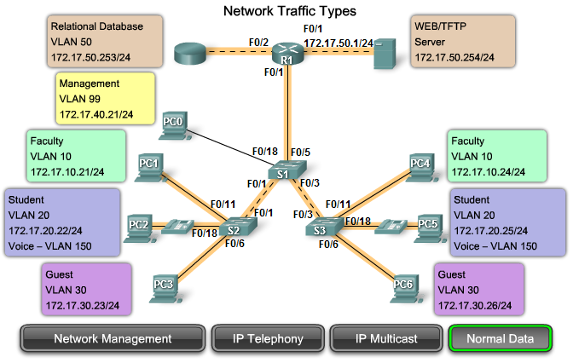

Scavenger Class
The Scavenger class is intended to provide less-than best-effort services to certain applications. Applications assigned to this class have little or no contribution to the organizational objectives of the enterprise and are typically entertainment oriented in nature. These include peer-to-peer media-sharing applications (KaZaa, Morpheus, Groekster, Napster, iMesh, and so on), gaming applications (Doom, Quake, Unreal Tournament, and so on), and any entertainment video applications.

Switch Port Membership Modes

Switch Ports
Switch ports are Layer 2-only interfaces associated with a physical port. Switch ports are used for managing the physical interface and associated Layer 2 protocols. They do not handle routing or bridging. Switch ports belong to one or more VLANs.

VLAN Switch Port Modes
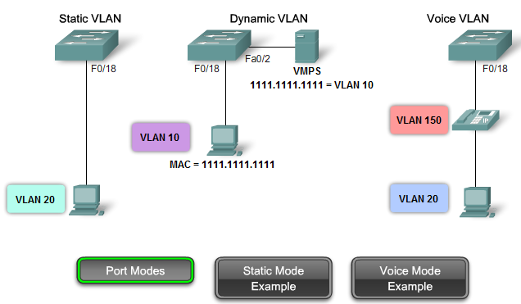
When you configure a VLAN, you must assign it a number ID, and you can optionally give it a name. The purpose of VLAN implementations is to judiciously associate ports with particular VLANs. You configure the port to forward a frame to a specific VLAN. As mentioned previously, you can configure a VLAN in voice mode to support voice and data traffic coming from a Cisco IP phone. You can configure a port to belong to a VLAN by assigning a membership mode that specifies the kind of traffic the port carries and the VLANs to which it can belong. A port can be configured to support these VLAN types:
- Static VLAN - Ports on a switch are manually assigned to a VLAN. Static VLANs are configured using the Cisco CLI. This can also be accomplished with GUI management applications, such as the Cisco Network Assistant. However, a convenient feature of the CLI is that if you assign an interface to a VLAN that does not exist, the new VLAN is created for you. To see a sample static-VLAN configuration, click the Static Mode Example button in the figure. When you are done, click the Port Modes button in the figure. This configuration will not be examined in detail now. You will see this configuration later in the chapter.
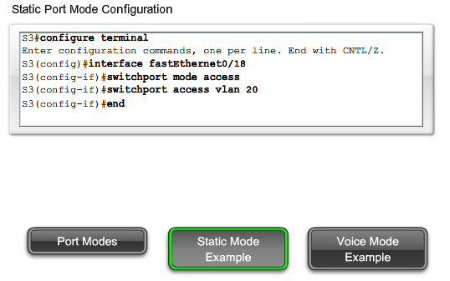
- Dynamic VLAN - This mode is not widely used in production networks and is not explored in this course. However, it is useful to know what a dynamic VLAN is. A dynamic port VLAN membership is configured using a special server called a VLAN Membership Policy Server (VMPS). With the VMPS, you assign switch ports to VLANs dynamically, based on the source MAC address of the device connected to the port. The benefit comes when you move a host from a port on one switch in the network to a port on another switch in the network-the switch dynamically assigns the new port to the proper VLAN for that host.
- Voice VLAN - A port is configured to be in voice mode so that it can support an IP phone attached to it. Before you configure a voice VLAN on the port, you need to first configure a VLAN for voice and a VLAN for data. In the figure, VLAN 150 is the voice VLAN, and VLAN 20 is the data VLAN. It is assumed that the network has been configured to ensure that voice traffic can be transmitted with a priority status over the network. When a phone is first plugged into a switch port that is in voice mode, the switch port sends messages to the phone providing the phone with the appropriate voice VLAN ID and configuration. The IP phone tags the voice frames with the voice VLAN ID and forwards all voice traffic through the voice VLAN.
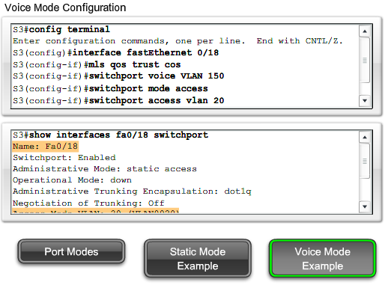
- The configuration command mls qos trust cos ensures that voice traffic is identified as priority traffic. Remember that the entire network must be set up to prioritize voice traffic. You cannot just configure the port with this command.
- The switchport voice VLAN 150 command identifies VLAN 150 as the voice VLAN. You can see this verified in the bottom screen capture: Voice VLAN: 150 (VLAN0150).
- The switchport access VLAN 20 command configures VLAN 20 as the access mode (data) VLAN. You can see this verified in the bottom screen capture: Access Mode VLAN: 20 (VLAN0020).

